

A Project Report

On

**“SPAM DETECTION”**

Batch Details

|  |  |  |
| --- | --- | --- |
| Sl. No. | Roll Number | Student Name |
| 1 | 20211CSE0196 | Eshaan Khuana |
| 2 | 20211CSE0230 | Charan Kumar S |
| 3 | 20211CSE0550 | Gagana Sindhu B M |
| 4 | 20211CSE0140 | Hisham |

**School of Computer Science,**

**Presidency University, Bengaluru.**

Under the guidance of,

Dr. Chandra Sekhar M ,Professor,

School of Computer Science,

Presidency University, Bengaluru

**CONTENTS**

1. Introduction about Project 1
2. Literature Review 2
3. Objectives 3
4. Methodology 4
5. Data Flow Diagram 5
6. Expected Outcomes 6
7. Timeline for Execution of Project 7
8. Conclusion 8
9. References 9

**Introduction**

Spam Detection:

A critical component in modern communication systems.To protect the user from various cyber crimes, i.e. Phishing or Malware.It plays a vital role in maintaining the efficiency, security, and overall integrity of communication systems, particularly in email, social media, and messaging platforms, therefore making it necessary for these communication channels to be safeguarded by a modern and effective software which will effectively adapt itself to tackle the situation at hand.

**Literature Review**

Traditional Spam Detection Techniques : Early spam filters, such as those based on **rule-based systems** and **Bayesian filters** (Sahami et al., 1998), focused on keyword matching and probabilities. While these techniques were effective initially, they lacked the adaptability to handle evolving spam tactics such as text obfuscation, leading to high false positive/negative rates.

**Machine Learning in Spam Detection:Machine learning models** introduced a data-driven approach. **Support Vector Machines (SVMs)** and **Naïve Bayes classifiers** were widely adopted for text-based spam detection (Carreras and Marquez, 2001). These methods showed improvements over rule-based systems, but they required significant manual feature extraction, limiting their ability to adapt to new spam techniques.

Deep Learning Approaches : Deep learning revolutionized spam detection by automating feature extraction. **Recurrent Neural Networks (RNNs)** and **Long Short-Term Memory (LSTM)** networks (Hochreiter and Schmidhuber, 1997) demonstrated strong performance by capturing patterns in email sequences. **Cao et al. (2018)** applied LSTMs for spam detection, showing notable improvements in identifying subtle text patterns.**Transformer models** like **BERT** (Devlin et al., 2018) brought a new level of sophistication by analyzing context and meaning in text, greatly enhancing the detection of complex and disguised spam.

**Hybrid Models :** Hybrid models have combined traditional ML with deep learning for improved performance. **Almeida et al. (2019)** combined **CNNs** for feature extraction with **Random Forests** for classification, resulting in enhanced accuracy and speed. Hybrid models exploit the strengths of different algorithms to better handle diverse spam content.

**Objectives**

* **Improve Detection Accuracy and Reduce False Positives/Negatives**
* **Adapt to Evolving Spam Techniques**
* **Leverage Multimodal Data for Comprehensive Detection**
* **Continuous Monitoring and Feedback Integration**

**Methodology**

1. Graph-Based Spam Detection for Sender Behavior Analysis:

Use graph-based models to analyze communication patterns between senders and recipients.

2. Context-Aware Spam Detection Using NLP and Sentiment Analysis:

Implement context-aware spam detection by integrating natural language processing (NLP) techniques such as sentiment analysis, topic modeling, and contextual embeddings (e.g., BERT, GPT) to better understand the intent behind a message.

3. Multimodal Spam Detection:

Develop a multimodal spam detection system that combines different data modalities (e.g.,text, images, attachments, and links). This method integrates image recognition for detecting malicious images, URL analysis for suspicious links, and text analysis for detecting spam content.

**Data Flow Diagram**

Communication Server

Message Preprocessing

Feature Extraction

Spam Classification

Post-Processing

Email Database

Spam Database

**Expected Outcomes**

* Increased Detection Accuracy and Precision
* Enhanced Adaptability to Evolving Spam Tactics
* Improved Detection of Multimodal Spam
* Continual Learning and Reduced Need for Manual Updates.

**Timeline Of The Project**

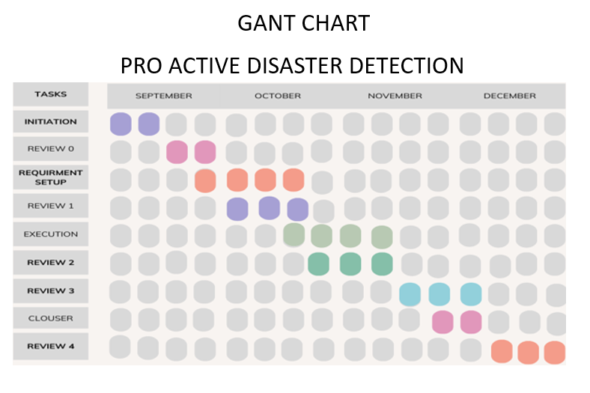

**Conclusion**

An improved and efficient version of spam detection presented infront of the world.Using various AI and ML methods to make an updated and better version of the spam detection software which is currently present on the internet.

**References**

[Francisco Jáñez-Martino](https://link.springer.com/article/10.1007/s10462-022-10195-4" \l "auth-Francisco-J__ez_Martino-Aff1-Aff2), [Rocío Alaiz-Rodríguez](https://link.springer.com/article/10.1007/s10462-022-10195-4" \l "auth-Roc_o-Alaiz_Rodr_guez-Aff1-Aff2), [Víctor González-Castro](https://link.springer.com/article/10.1007/s10462-022-10195-4" \l "auth-V_ctor-Gonz_lez_Castro-Aff1-Aff2), [Eduardo Fidalgo](https://link.springer.com/article/10.1007/s10462-022-10195-4" \l "auth-Eduardo-Fidalgo-Aff1-Aff2) & [Enrique Alegre](https://link.springer.com/article/10.1007/s10462-022-10195-4" \l "auth-Enrique-Alegre-Aff1-Aff2)  (2022). [Handling Concept Drift in Spam Detection](https://link.springer.com/article/10.1007/s10462-022-10195-4)

.

Mohammad Tubishat Feras Al-Obeidat Ali Safaa Sadiq Seyedali Mirjalili (2023) . [Improved Dandelion Optimizer Algorithm for Spam Detection: Next-Generation Email Filtering System.](https://www.mdpi.com/2073-431X/12/10/196)

Konstantinos I. Roumeliotis Nikolaos D. Tselikas and Dimitrios K. Nasiopoulos (2024). [Fine-Tuning Large Language Models (LLMs) for Spam Filtering](https://www.mdpi.com/2079-9292/13/11/2034)

Thashina Sultana, K A Sapnaz, Fathima Sana, Mrs. Jamedar Najath (2020). [Email based Spam Detection](https://www.ijert.org/research/email-based-spam-detection-IJERTV9IS060087.pdf)